Project Design Phase-II

Data Flow Diagram & User Stories

|  |  |
| --- | --- |
| Date | 18 October 2022 |
| Team ID | PNT2022TMID45551 |
| Project Name | Project – Global Sales Data Analytics |
| Maximum Marks | 4 Marks |

# Data Flow Diagrams:

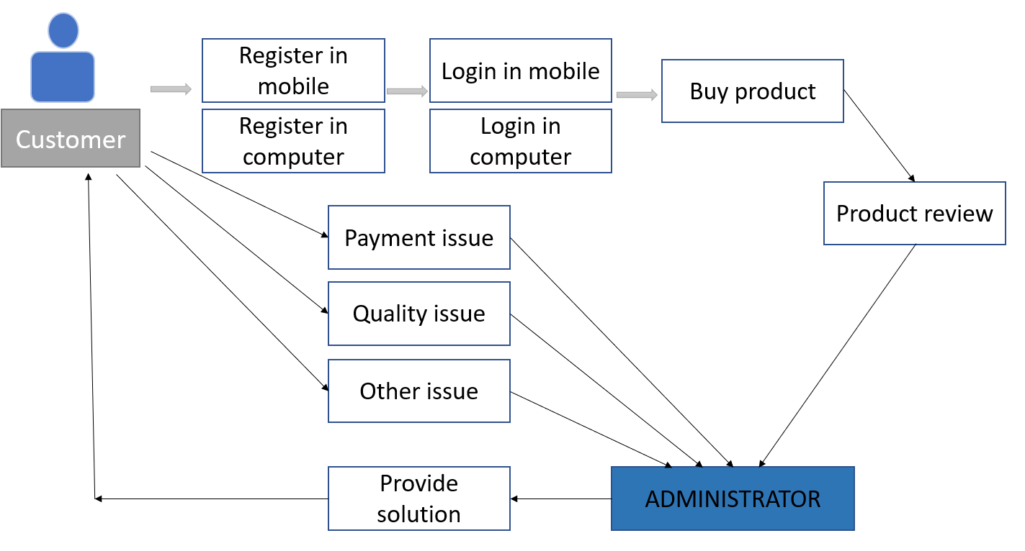

**User Stories**

|  |  |  |  |  |  |  |
| --- | --- | --- | --- | --- | --- | --- |
| **User Type** | **Functional**  **Requirement (Epic)** | **User Story Number** | **User Story / Task** | **Acceptance criteria** | **Priority** | **Release** |
| Customer (Mobile user) | Registration | USN-1 | As a user, I can register for the application by entering my email, password, and confirming my password. | I can access my account / dashboard | High | Sprint-1 |
| USN-2 | As a user, I will receive confirmation email once I have registered for the application | I can receive confirmation email & click confirm | High | Sprint-1 |
| Login | USN-1 | As a user, I can log into the application by entering email & password |  | High | Sprint-1 |
| USN-2 | As a user, I can log into the application by entering mobile & password |  | High | Sprint-1 |
| Customer (Web user) | Registration | USN-1 | As a user, I can register for the application by entering my email, password, and confirming my password. | I can access my account / dashboard | High | Sprint-1 |
| USN-2 | As a user, I will receive confirmation email once I have registered for the application | I can receive confirmation email & click confirm | High | Sprint-1 |
| Login | USN-1 | As a user, I can log into the application by entering email & password |  | High | Sprint-1 |
| USN-1 | As a user, I can log into the application by entering mobile & password |  | High | Sprint-1 |
| Customer Care Executive | Difficulties | USN-1 | Change the product | I can be done by single click in customer support option | Medium | Sprint-1 |
| USN-2 | Make the payment method change | I can change the payment mode easily and many possibilities are available | Medium | Sprint-1 |
| ‘Administrator | Product Quality Issue | USN-1 | Product received is damaged | After I put the product status in web, the administrator contacts me and resolve the issue | Medium | Sprint-1 |
| USN-2 | Product not able to track | Using the support option I rise the query, and my problem will be noticed and resolved | Medium | Sprint-1 |